Interactive Community Call Handout

Facilitating and building engaging digital meetings can be a challenging experience for anyone. However, digital team bonding activities can help build community and strengthen already existing relationships regardless of physical distance. Use this interactive handout with guiding questions to write down your reflections on the team bonding activities presented today.

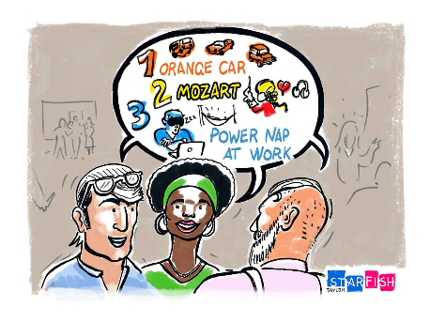Activity 1: 10 Things

**Objective:** Find 10 things everyone in your assigned group has in common.

**Key Features:** Large group compatible, ideal for groups looking to bond deeper, and requires everyone to participate.

**Directions:** Participants will be broken up into groups of 10 or more. Each group will choose one group member to report out their commonalities. Groups will have 12 minutes to figure out the 10 things they have in common.

<https://www.starfishtaylor.com/team-building-icebreaker/>

Reflection 1: 10 Things

***How did you feel as a participant? Was the activity fun? What helpful information do you think participants learned for each other? Are virtual breakout rooms needed for this activity? Did this activity engage everyone? Was the activity too complicated that it may have frustrated or confused participants? Was the activity too short and simple that it bored the participants? Any additional objectives or rules you would include to challenge participants more?***

Activity 2: Aliens have Landed

**Objective:** Correctly describe a person, place or thing to the Aliens who have just landed.

**Key Features:** Large group compatible, spurs creativity, and allows for the option for participants to observe if they choose to.

**Directions:** Aliens have landed on earth. They don't know the name for anything. Non-aliens will be provided a category (such as people, places, household objects, etc.) and will be asked to think of an item within that category to describe. They will have 30 seconds to describe their chosen object in 30 seconds using 5 words or less. Everyone else (Aliens) will write their guesses in the chat box.

<https://miro.com/blog/resources/guide-effective-remote-brainstorming/ice-breaking-games-remote-teams/>

Reflection 2: Aliens have Landed

What is right for you?

***How did you feel as a participant? Was the activity fun? What helpful information do you think participants learned for each other? Are virtual breakout rooms needed for this activity? Did this activity engage everyone? Was the activity too complicated that it may have frustrated or confused participants? Was the activity too short and simple that it bored the participants? Any additional objectives or rules you would include to challenge participants more?***

Use the remaining reflection section below to decide on which team bonding activity you would like to try for your next League meeting. Remember choosing an activity will vary upon the needs and goals that you have for your League.

<https://miro.com/blog/resources/guide-effective-remote-brainstorming/ice-breaking-games-remote-teams/>

Reflection 3: What is right for you?

***What are your goals for your League? Who is your exact audience? (volunteers, league members, etc.) How long will the activity take? How many participants do you have? Is the team bonding activity connected to a certain purpose in your meeting?***

Additional Resources:

* Contact [organizing@lwv.org](mailto:organizing@lwv.org) with any questions, comments or feedback.
* Check out the [Organizing resource page](https://www.lwv.org/league-management/recruitment-engagement/organizing-resources-build-league-power) on the League management site.
* [May 21st](https://www.lwv.org/league-management/recruitment-engagement/organizing-resources-build-league-power) Team Building and Facilitating using Digital Platforms Training from 3-4 ET.